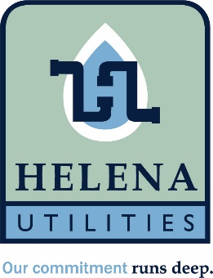

Helena Utility Board
May 18th, 2026
Helena Municipal Building
10 Jack Gray Way

Attendance: (P) Present (A) Absent (D) Delegated
 | Rhonda Lewis |  | Jeffrey Nelson
 | Kim Ray |  | Teresa Amos
 | Charlie Roberts
 | Dennis Wilson
Guests:

Meeting called to order

Prayer

Approve minutes from March meeting

Review bills paid

Audit fy 2025 presentation by Walker Gann

Discussion on increasing Utility Board members and clarification on terms.

Discussion of discount rates for fixed/low-income customers

Discussion on Travel policy.

