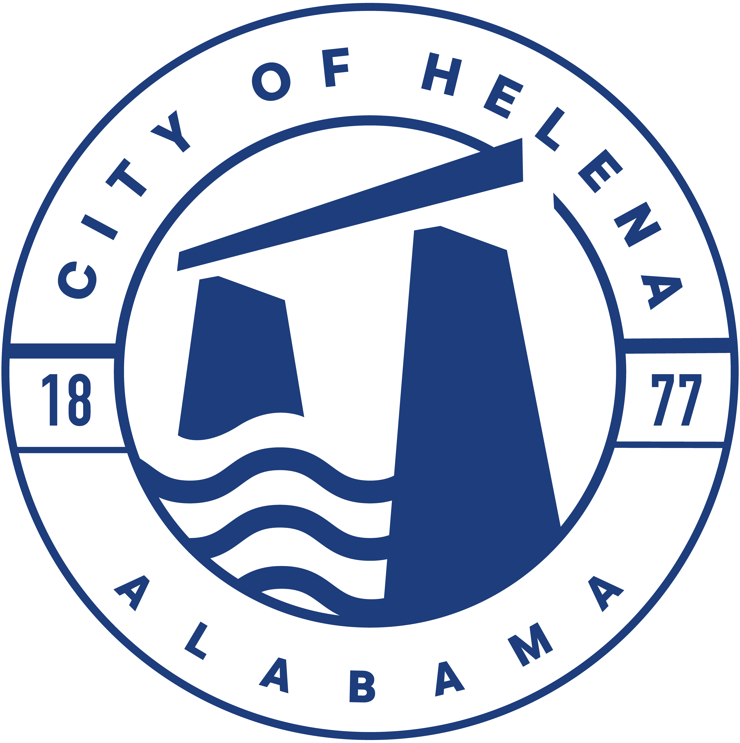
10 Jack Gray Way, Helena, AL 35080
City Hall Council Chambers
Helena Board of Adjustments May 15, 2026
Agenda 8:00am

Meeting Called to Order

Prayer

Pledge of Allegiance

Roll Call

Approval/Correction of Minutes

Unfinished Business

Hearing of Applications

Approve/Deny variance request 4969 Highway 17 B-2 requesting a variance for a pole sign allowed which is 30 feet to be seen over the O’Reilly’s Auto parts store sign. This request is for a variance of 16 feet from existing signage.
Committee Reports

Resolutions

Communications and Miscellaneous Business

Adjourn

