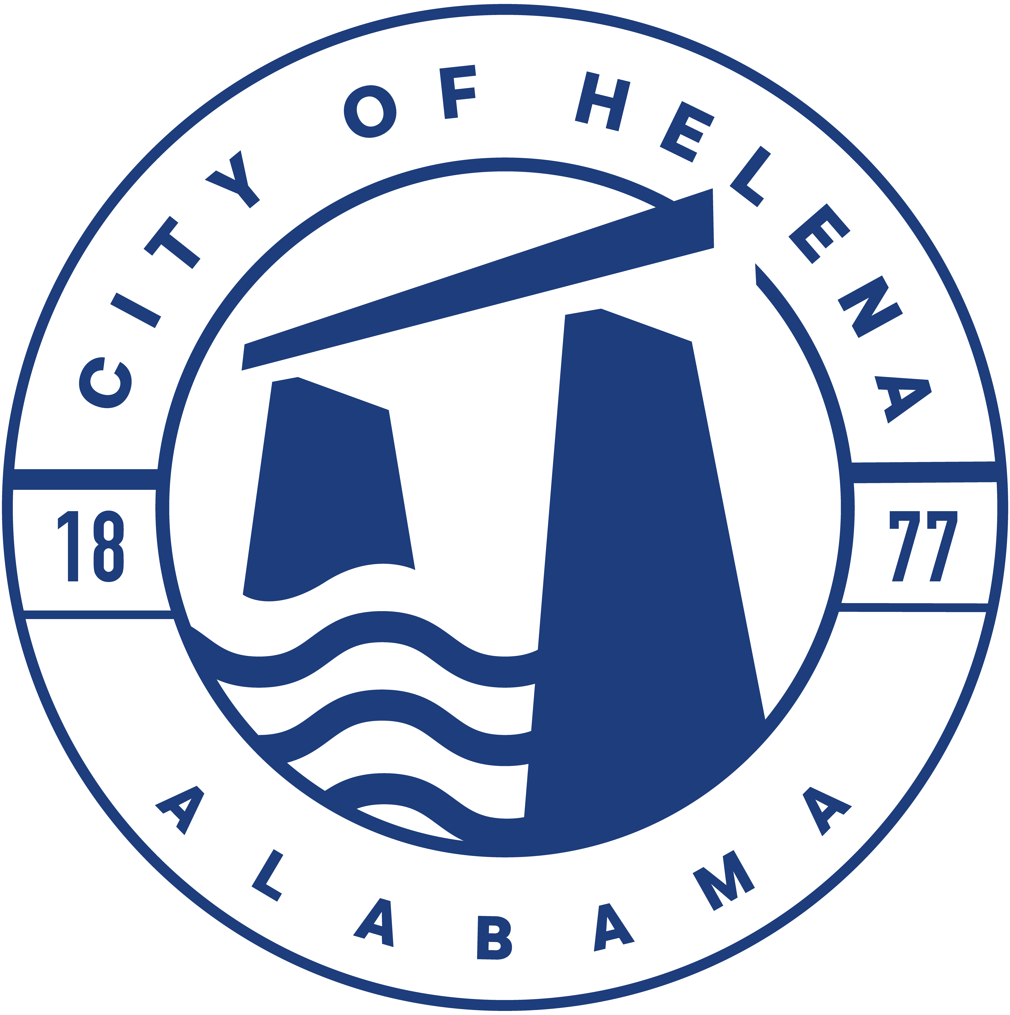
Helena HOTBoard July 2, 2026 6:00 p.m.
Regular Meeting Helena Amphitheater Park

Introduction
  - Chairman calls the meeting to order.
  - Roll Call.
  - Presentation of Meeting Minutes from June 12, 2026

Chairman Opening Remarks.

- Old Town Live 2026

- HOTBoard Social Media and webpage

- New Business

- Treasurer’s Report

- Other/Open Discussion

- Confirm next meeting date and time.

- Adjournment

Meeting Attendees:
X | Name | Name
 | Jeremy Allen |  | John Barnes
 | Brian Hayes |  | JoAnna Harman
 | Jake Rasmussen |  | Nathan Bailey
 | Jay Harman |  | Tony Middleton
 | Jonathan Hollabaugh
 | Dennis Wilson - Liaison

