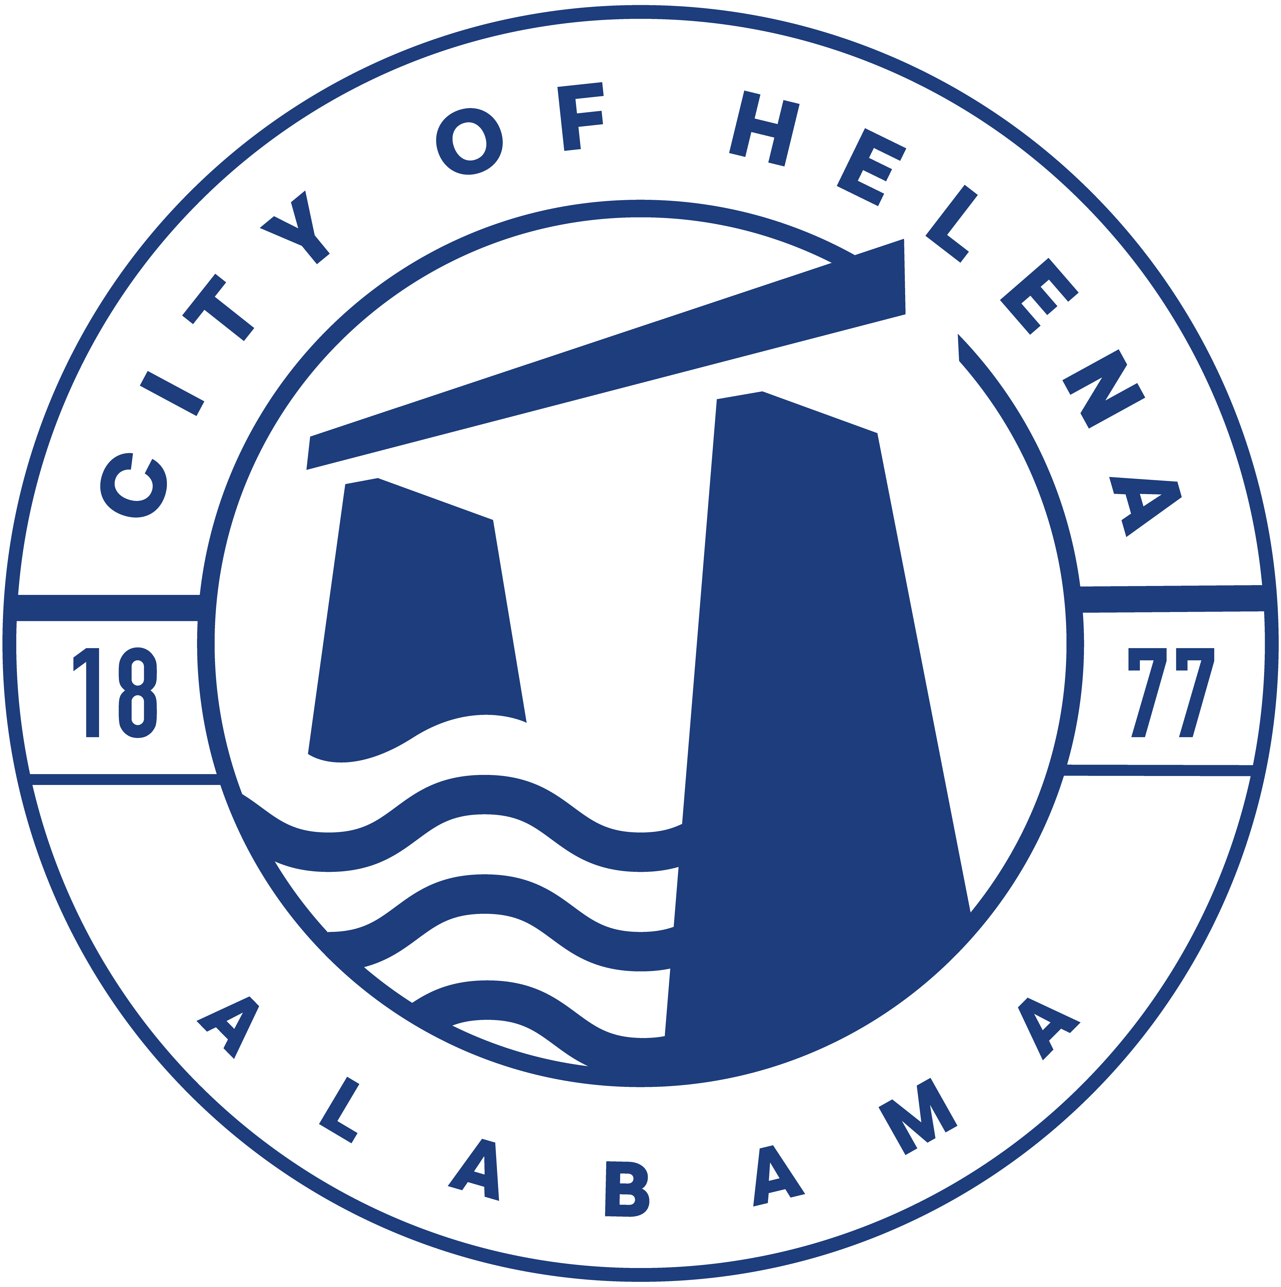
Helena HOTBoard July 2, 2026 at 6:00 p.m.
Regular Meeting Helena Sports Complex

Attendance: (P) Present (A) Absent (C) Call In
P | Jeremy Allen | P | John Barnes
A | Jake Rasmussen | P | JoAnna Harman
P | Brian Hayes | P | Nathan Bailey
P | Jay Harman | P | Tony Middleton
P | Jonathan Hollabaugh
 |  | A | Council Liaison Dennis Wilson

Guests:
 | Jay Wellborn |  | Bob Hammann
 | Billy Rosener

Introduction
  - Chair Jeremy Allen, called the meeting to order at 6:04 p.m.
  - Roll Call and a quorum is present.
  - Presentation of Meeting Minutes from June 12 2026.
  - Motion to accept the Minutes from June 12, 2026 was made by Brian Hayes and seconded
by John Barnes.
  - Motion carried with Eight (8) in favor and none opposed.

Chairman’s Opening Remarks
- Tomorrow will be hot – but excited about this event!

- Old Town Live
- We have 400 hats for sale. Monsters of Yacht will not be selling any Captain’s hats. Priced at $10 for sale. Giving some out on VIP.
- Two porta potties are across street.
- There are tables and 60 chairs setup up in The Depot’s parking lot.
- Full Moon catering VIP and feeding bands. Should arrive around 4:45.
- 8:45 there will be a reading of the Declaration of Independence recorded by Rick Carter. Getting Amerian Flag from City Hall and will have representatives from every branch of the service carrying their flag.
- Monsters of Yacht will play during fireworks.
- Seventeen to 20 minutes of fireworks.
- Next years July 3rd band has been booked.

- HOTBoard Social Media and webpage
  - Over the past 7 days there have been 137,000 views and 78 new followers.
  - AI helping to answer basic inquiries to the FB page
  - There was a discussion about a video from Cowboy Mouth. Team decided to leave it.

- New Business
  - None

- Treasurer’s Report
  - No report at this time.
  - Scheduling a meeting with Patti with the City to review.
  - FOHOT has $40k to finish out expenses for the rest of the season.

- Other/Open Discussion
- Brian asked the group to think about maybe doing a movie in June of next year.
- New stage is currently in production.

- Confirm Next Meeting Date and TIme
- Motion was made by Brian Hayes for the August meeting to be August 17th at 7pm at the Sports Complex. Seconded by John Barnes.
- Motion carried with Eight (8) in favor and none opposed.

- Adjournment
  - Motion to adjourn made at 6:24pm
  - Motion by Jeremy Allen and seconded by John Barnes.
  - Motion carried with Eight (8) in favor and none op
  - posed.

