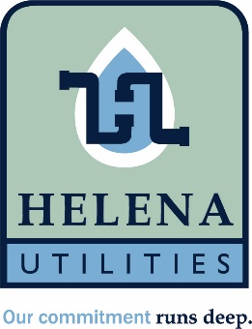

Helena Utility Board Special Meeting
June 23rd, 2026, 4:00 pm
Helena Municipal Building
10 Jack Gray Way
Helena, Al 35080

Meeting called to order

Present Official Statement Series 2026 Bond for board approval and signature

Adjourn

