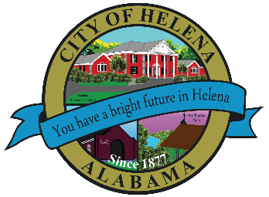
Helena Public Library Board Agenda July 30th, 2026 at 4:30PM
*MEETING TO BE HELD AT HELENA PUBLIC LIBRARY

Meeting Called to order

Roll Call

Minutes

New Business:

Item 1 Library Report

Item 2 Budget Report

Item 3 Grant Report

Item 3 APLS Code Change Update

Item 4 Long Range Plan Review

Old Business

Item 1 Required Document Review – By Laws (Time Permitting)

Item 2 Upcoming Board Meeting Dates

Other/Open Discussion

Public Comments

Adjourn

