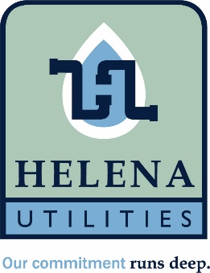

Helena Utility Board Regular Meeting
July 13, 2026 4 pm
Helena Municipal Building
10 Jack Gray Way
Helena, Al 35080

Meeting called to order

Approval of minutes from June 8th meeting.

Approval of June bills

Approve/Deny RSA retiree longevity bonus. Estimated cost to Helena Utilities is $2,572.00.

Approve/Deny Installation and payment of new windows at Hwy 52 building.

Review of travel and reduced rate policies

Update from General Manager

Adjourn

