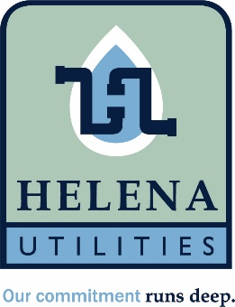

Helena Utility Board Regular Meeting
August 10th, 2026
Helena Municipal Building
10 Jack Gray Way
Helena, Al 35080

Meeting called to order

Approval of minutes from July 13th meeting.

Approval of July bills

Board discussion on adding additional members increasing number to five.

Review/discussion on reduced rate policy.

Discussion on strategic planning.

Update from General Manager

Adjourn

